

**QuizSite Project Documentation**

**Project Name:** QuizSite.

**This is the first project with the Orange Coding Academy.**

Team members:

1. Tasneem Abed Elah Sari Al-Shiyyab (Scrum Master).
2. Osama Anwer Ahmad Madi.
3. Mohammad Zaid Mohammad Shoqair.
4. Sondos Tarek Abd Al-Kareem Al-Jalowdi.
5. Nedal Maher Ahmad Daban.
6. Mustafa Sami Mustafa Yahia.

Table of Contents

1. Acknowledgment.
2. Abstract.
3. Development Methodology
4. System Architecture and Design.

4.1 Front-End Technologies.

4.2 Data Storage.

4.3 Integration with External APIs.

4.4 System Workflow.

### 4.5 Advantages of the Architecture.

1. Pages.
2. Features.
3. Conclusion.

Acknowledgment

We would like to express our sincere gratitude to the Orange Coding Academy for providing us with the opportunity to work on this project, QuizSite. This project has been an invaluable learning experience, and we appreciate the support, guidance, and resources provided by the academy.

We would also like to extend our heartfelt thanks to our coaches, **Reem Emad** and **Rawan Al-Halleeq**, for their continuous support, mentorship, and valuable feedback throughout the development process. Their expertise and guidance have played a key role in shaping the success of this project.

A special thanks to our team members for their hard work, collaboration, and commitment to making QuizSite a successful project. Each one of us has contributed unique skills and ideas, making this project truly a team effort.

Abstract

QuizSite is an interactive web application designed to help users learn English by providing quizzes tailored to various skill levels, from beginner to advanced. The platform offers a wide range of quizzes that cover different aspects of the English language, including vocabulary, grammar, sentence structure, and reading comprehension. By allowing users to engage in these quizzes, QuizSite aims to make language learning fun, interactive, and effective.

Developed by a team of students from the Orange Coding Academy, QuizSite was built using full-stack web technologies to ensure a responsive and user-friendly experience. The application features customizable quizzes, instant feedback, and a user-friendly interface that supports learners at different stages of their English language journey.

The project highlights our ability to create a seamless learning tool. QuizSite aims to make English learning more accessible and enjoyable for users of all ages, helping them track their progress and improve their language skills in an engaging way.

Development Methodology

To ensure efficient project delivery and smooth collaboration, we adopted focusing on team collaboration and task management. This approach allowed us to work iteratively and stay flexible, adapting to changes and continuously improving the project based on feedback.

Our success relied heavily on effective communication and collaboration among team members. We worked together to ensure that tasks were clearly understood, priorities were aligned, and issues were addressed promptly. Key strategies for collaboration included:

Daily Stand-ups: Short daily meetings helped us share progress updates, discuss any blockers, and stay focused on our goals.

Code Reviews: Regular code reviews fostered collaboration, ensuring that the quality of our code remained high and that everyone was aligned on the implementation.

We also made sure to maintain a collaborative environment, where everyone’s ideas were valued, and feedback was incorporated into the development process.

Task Management with Trillo

To keep our project on track, we utilized Trillo as our project management tool. Trillo allowed us to organize tasks, set priorities, and track the progress of each feature and bug fix. The tool helped us to:

System Architecture and Design

The architecture of the QuizSite application was designed to be lightweight and efficient, using modern front-end technologies and browser storage for data management. The system leverages APIs for enhanced functionality, ensuring a seamless user experience for learning English.

### 4.1 Front-End Technologies

The front-end of QuizSite is built using the following technologies:

* HTML: Used to structure the content of the application.
* CSS: Employed for styling and creating a visually appealing interface.
* JavaScript (DOM Manipulation): Used to handle dynamic interactions on the client side, providing users with an engaging and interactive experience.

### 4.2 Data Storage

For managing data on the client side, we utilize browser-based storage mechanisms:

* **Local Storage**: Used to store data that persists across sessions, such as user preferences or progress tracking.
* **Session Storage**: Used for temporary data storage that is cleared when the session ends, such as quiz answers for the current session.

### 4.3 Integration with External APIs

To provide an enriched learning experience, QuizSite integrates with the **YouTube API** to display relevant educational videos. These videos are carefully curated to align with the various learning levels available in the application, offering users supplementary resources to improve their English skills.

### 4.4 System Workflow

1. **User Interaction**:
   * Users interact with the interface built using HTML, CSS, and JavaScript.
   * Dynamic updates are performed using JavaScript to improve interactivity.
2. **Data Management**:
   * User-related data, such as progress and settings, is stored in **Local Storage**.
   * Temporary session-specific data, such as quiz answers, is managed using **Session Storage**.
3. **API Integration**:
   * The YouTube API fetches and displays relevant videos for users based on their learning level and preferences.

### 4.5 Advantages of the Architecture

* **Lightweight**: By using browser-based storage, the application avoids the need for complex server-side storage solutions.
* **Scalable**: APIs like YouTube allow the application to provide unlimited learning resources without increasing infrastructure complexity.
* **User-Friendly**: Front-end technologies ensure a clean, responsive, and interactive design for enhanced user experience.

Pages

* Welcoming page:

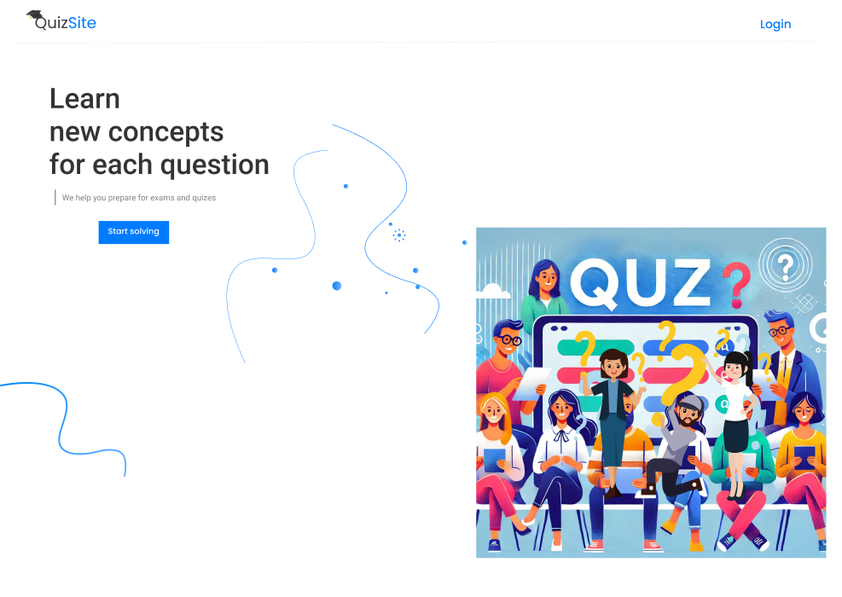

The welcoming page is the user’s first interaction with Quiz Site. It serves as the gateway to the site and includes:

1. Login Form: Allows returning users to access their accounts by entering their credentials (email and password). A "Remember Me" option is provided to make future logins more convenient by saving login credentials on the device.
2. Registration Form: Enables new users to create an account by providing basic details such as name, email, and password. Validation ensures accurate and secure input.
3. Introduction to Quiz Site: A brief description or tagline about the site's purpose, displayed prominently to engage users.

The welcoming page is designed to be responsive and accessible, ensuring users have a smooth start to their learning journey, regardless of the device they use.

* Levels page:

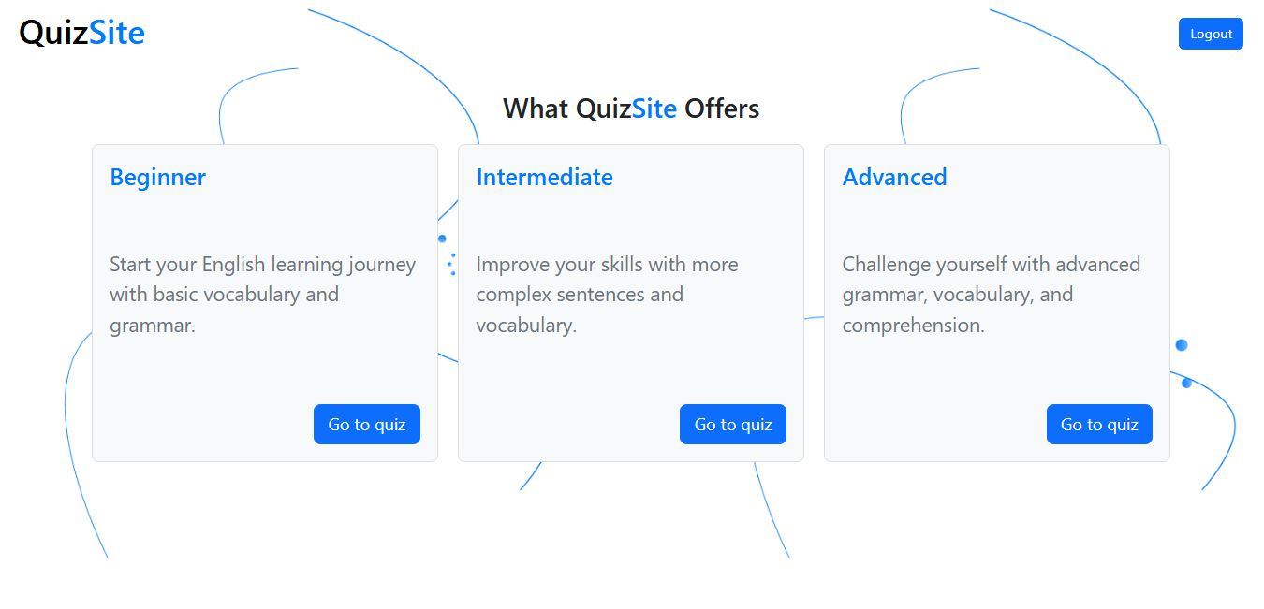

The levels page is where users select their desired proficiency level to begin their quiz. This page ensures that users are directed to a quiz that matches their current skill set.

It includes the following features:

1. Level Options: Three distinct sections "Beginner," "Intermediate," and "Advanced," allowing users to clearly see and choose their desired level.
2. Dynamic Navigation: Once a user selects a level, they are seamlessly redirected to the corresponding quiz page tailored to the chosen difficulty.
3. Visual Indicators: Vibrant colors or icons associated with each level make it visually engaging and help users quickly identify their choice.
4. Consistency: The page design follows the same responsive and user-friendly principles as the rest of the platform, ensuring accessibility on all devices.

The levels page is a crucial step in the user journey, as it provides a personalized entry point into the quizzes, enhancing the learning experience by addressing individual needs and goals.

* tutorial page:

The Tutorial Page serves as the core learning resource for users, providing video-based lessons to teach the English language effectively. It integrates multimedia content and user-friendly features to enhance the learning experience.

* 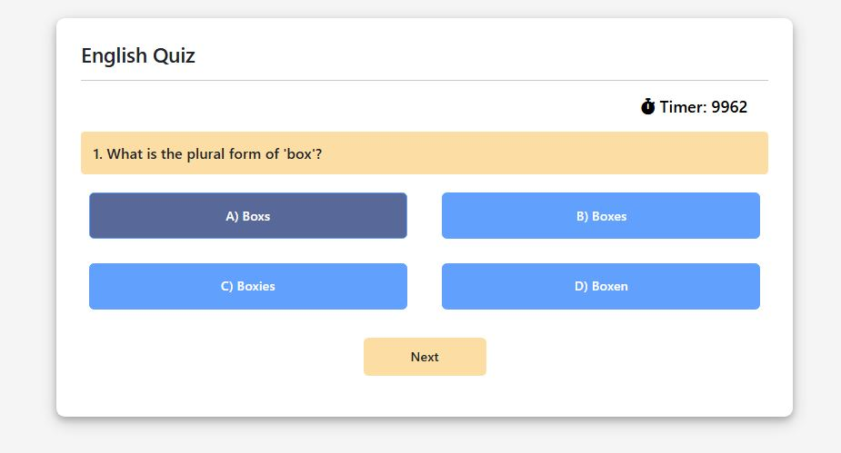Quiz page:

The Quiz Page is an interactive feature of the QuizSite application that allows users to test their English language skills. The quizzes are tailored to different learning levels, ensuring users can assess their progress and reinforce their knowledge.

* Result page

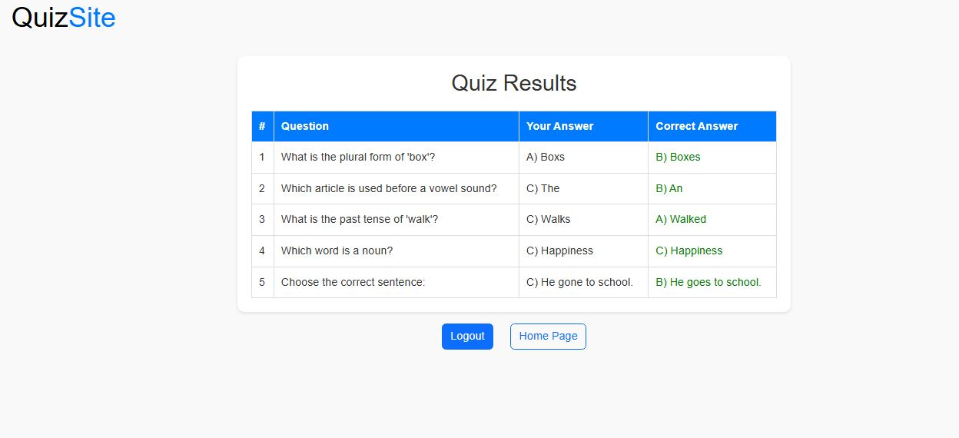

The **Result Page** provides users with a detailed summary of their quiz performance. It displays the results in a clear and structured format, allowing users to review their answers and learn from their mistakes.

Features

QuizSite is designed to provide an interactive, user-friendly, and effective learning experience for users at different levels of English proficiency. Below are the key features categorized based on their contribution to learning, user experience (UX), user interface (UI), readability, and overall engagement.

1. Learning Features

### Level-Based Learning

* The content is divided into levels (Beginner, Intermediate, Advanced), ensuring tailored material for each user's skill set.
* Clear progression paths motivate users to complete levels and advance.

### Video-Based Tutorials

* Integration with YouTube API provides access to high-quality educational videos.
* Level-appropriate content improves listening, vocabulary, and grammar skills.

### Quizzes for Assessment

* Timed, level-based quizzes with immediate feedback help users test their knowledge.
* Questions are designed to reinforce learning objectives and encourage retention.

1. User Experience (UX) Features

### Intuitive Navigation

* The website offers simple and intuitive navigation, making it easy for users to switch between tutorials, quizzes, and results pages.
* A structured menu and links improve accessibility for all users.

### Engagement and Motivation

* Timed quizzes with dynamic feedback create a gamified experience, increasing user engagement.
* Encouraging messages and progress tracking help users stay motivated.

### Mobile Responsiveness

* The website is fully optimized for mobile devices, ensuring seamless usability on smaller screens.

### Feedback System

* Users receive instant feedback on quizzes and tutorials, allowing them to learn from mistakes.

## 3. User Interface (UI) Features

### Clean and Modern Design

* A visually appealing layout with consistent use of colors, fonts, and spacing ensures a professional and inviting appearance.
* Minimalistic design reduces cognitive load and enhances focus on learning content.

### Interactive Elements

* Buttons, timers, and visual feedback (e.g., highlighted correct answers) provide a dynamic and engaging experience.
* Responsive design ensures that all elements adjust smoothly to various screen sizes.

## 4. Readability Features

### Accessible Content

* All text is written in simple, clear, and concise language to accommodate users with varying English proficiencies.
* Large fonts and adequate line spacing enhance readability.

### Tutorial Layout

* Videos and supplementary text are organized logically, allowing users to follow along without confusion.
* Subtitles for videos improve comprehension, especially for non-native speakers.

### Table-Based Results

* The results page presents data in a tabular format, simplifying the review process.
* Highlighted rows and color-coded feedback make it easy to distinguish correct and incorrect answers.

## 5. Technical and Performance Features

### Fast Load Times

* Lightweight code and efficient use of APIs ensure fast page loading, even on slower connections.
* Local storage minimizes server dependency for storing user progress and preferences.

### Browser Compatibility

* The website is tested to work smoothly across all major browsers, ensuring a consistent experience.

### Error Handling

* Friendly error messages guide users if an issue arises, such as a failed API call or incomplete quiz submission.

## 6. Accessibility and Inclusivity

### Keyboard and Screen Reader Support

* The website is designed to be accessible for users with disabilities, with keyboard navigation and compatibility with screen readers.

### Multi-Device Usability

* The responsive design ensures the website works equally well on desktops, tablets, and smartphones.

### Benefits of QuizSite Design

* **Effective Learning**: Combines tutorials, quizzes, and progress tracking to create a comprehensive learning platform.
* **User Engagement**: Gamified elements and motivational features encourage users to continue learning.
* **Professional Appearance**: Clean UI and responsive design establish credibility and trust.
* **Inclusive Accessibility**: Features that accommodate diverse user needs ensure a wide reach.

Conclusion

QuizSite is a thoughtfully designed platform that provides an engaging and interactive way for users to learn English. By combining video-based tutorials, timed quizzes, and progress tracking, the system caters to learners of all levels and helps them improve their language skills effectively. The use of modern technologies like HTML, CSS, JavaScript, and APIs ensures a seamless and responsive user experience.

The project emphasizes user-centric design principles, offering an intuitive interface and features that enhance readability and accessibility. From structured learning paths to instant feedback mechanisms, QuizSite creates an environment that motivates users to achieve their learning goals.

Through collaboration and effective task management using tools like Trillo, the team successfully developed a scalable and efficient system. With potential for growth and monetization, QuizSite serves as both a practical learning tool and a strong foundation for future development.

QuizSite demonstrates the power of teamwork, innovative design, and technology in addressing educational challenges, making it a valuable contribution to the field of online learning.